Forming and Supporting an Ag-Informed Generation
Through Agriculture Education:

A Proposal to Implement Agriculture Education in
High Schools Across the United States of America

Sarabeth Royer
The Pennsylvania State University
Spring 2013

An Open Letter to:
United States Department of Education,
United States Department of Agriculture,
And School Boards across the United States,

Forming and Supporting an Ag-Informed Generation
Through Agriculture Education
This is a proposal for the implementation of agricultural education in every public high school in the United States. This proposal addresses the key facets of how having an upcoming generation of agriculturally literate citizens will aid the United States of America’s economy, will help students become more well-informed consumers, will encourage more environmentally friendly practices, and will sustain the food security of the future. This proposal also identifies possible problems, and ways to overcome them. These include financial burdens, having enough educators trained in agriculture, and a way to effectively transition the American school system to enable education in and about agriculture.
In The Barn, An Idea is Born
This may come as a surprise to many people, but the idea for this proposal came to me while milking cows on my family’s dairy and poultry farm in Lancaster County, Pennsylvania. I was surveying the cows in the barn and a rush of pride, genuine joy and contentment coursed through me. This euphoric feeling, however, was soon overshadowed by the dark stigma of society’s many stereotypes and misconceptions about agriculture. There are many people who don’t understand, and even look down upon agriculture; a way of life that my family is very proud of. I have become increasingly aware of the fact that people simply do not realize the incredible opportunities, diversity in operations, and creative innovation that takes place in agriculture. There is a disheartening disconnect between the consumer and producer. This disconnect occurs between someone opening the door of their refrigerator, and someone opening the door of a tractor. The truth is that few Americans truly know where that food in the grocery store originated from, nor the hard work that was poured into that product in the isle. A way to end this deficit of knowledge is education, and I believe that high schools across the entire United States of America should offer courses on agriculture. I will be the first one to tell you that my agriculture education classes in high school helped to shape me into the person I am today. I also want people to realize the opportunities of agriculture education (Ag Ed.)
In the Ag Ed classes at my high school, it was not just the poinsettias and rabbits that were growing, but also the students. Our teachers instilled in us not only knowledge, but the importance of hard-work, cooperation, communication, innovation, and most importantly, to believe in ourselves. In Ag Ed, nature is our canvass. We examine the beauty of life in hatching chicks, and in rows of corn. We discuss sustainability, and the importance of good, honest, hard work. We get our hands dirty by planting flowers around the school, or by volunteering at a garden for a food bank. In Ag Ed, we learn how to speak clearly when discussing the merits of livestock, and have the incredible opportunity to work together to solve problems. Just as the flowers we plant have the opportunity to blossom, students grow and bloom in an environment where learning is hands-on and the opportunities are endless. I can honestly say that I would not be a freshman at the Pennsylvania State University in the Schreyer Honors College without my years in Ag Ed. I am proud to be a part of the College of Agricultural Sciences, and desire for others to know about this industry that I love.
Plants are so simple. They start as mere seeds, but the ones with the deepest and farthest reaching roots flourish to become the tallest, strongest plants. This proposal may have humble origins, but many great ideas are born in barns. My original thought, while standing in the barn, was that America needs to get back to its roots in agriculture. I wrote this proposal because I sincerely believe that the United States of America can become a stronger nation if its citizens have a better understanding of agriculture.
What is Agriculture Education?
To propose that every public school in the United States support agriculture education classes as an option for students is a very grandiose idea, and was not thought of lightly. This is an extremely financially burdensome proposal in a time where school districts across the U.S. are enduring budget deficits. However, in looking at the benefits of agriculture education, having a more agriculturally knowledgeable future generation will increase the standard of living for many Americans. Agriculture education involves implementing subjects already taught, such as math, science, and communication, into the nation’s largest industry, agriculture, which can be defined as the production of food, fuel, and fiber. ¹ Currently the United States produces the world’s safest, most abundant and affordable food. ¹ However, this will not continue if future generations are not trained in agriculture and its many facets.
Agriculture education functions like any other class in the high school. The only difference is that instead of learning about Barium in Chemistry, students learn about Bovine (cows and bulls.) In place of learning solely algebra, students may solve efficiency problems, such as “how many acres of corn should they grow in order to optimize profits?” While many people believe that this is outdated and irrelevant, many students in Ag Ed find it easier to learn with such real-life examples. There are many incredible opportunities to learn about subjects like; animal science, plant science, trade skills (shop, carpentry, welding) the diverse careers in agriculture, the history and future of ag, and much more. Classes cultivate real life applications with science, math, and teamwork to enable students to gain skills that aren’t often taught in other classes. ²
There are many misconceptions about agriculture, and Ag Ed programs. This proposal, to enable more students to take agriculture education classes in school, also aims to eradicate these negative connotations associated with the industry. There is the idea that Ag is outdated, traditional, and consists of uneducated men. However, in reality, modern American agriculture involves men and women. It is innovative, scientific, constantly becoming more efficient, and providing citizens of the world with excellent quality food, fuel, and fiber. For an industry that affects everyone when they open the refrigerator or put on a cotton shirt, it is about time that high schools across the U.S. provided a proper education in agriculture and its many opportunities. As the average American consumer becomes generations away from the traditional “family farm,” they lose track of how important this industry is. Agriculture education can help Americans realize where the food on their plate, the clothes on their back, and the houses they live in, really come from, while also creating a stronger, healthier American society.

Benefits of Agriculture Education for the United States:
Economy:
The United States economy has had a rich, prosperous tradition in Agriculture that continues still today. Thomas Jefferson wrote in a letter to George Washington in 1787, “Agriculture is our wisest pursuit, because it will in the end contribute most to real wealth, good morals, and happiness” ³ Currently, agriculture is still the nation’s leading industry. United States Secretary of Agriculture, Tom Vilsack stated in a speech in 2011 that, “1 out of every 12 jobs in the economy is connected in some way, shape or form to what happens on the farm.” ¹ Looking to the future, the industry has even more room to grow, and increasingly more apparent ways to impact the economy positively. In a 2010 study on projected employment opportunities in Agriculture, the United States Department of Agriculture (USDA), in partnership with Purdue University, found tremendous areas for growth. They list four major factors that shape the market for graduates: “(1) macroeconomic conditions and retirements, (2) consumer preferences for nutritious and safe foods, (3) food, energy, and environment public policy choices, (4) global market shifts in population, income, food, and energy.” ⁴ In this projection, experts also identified a staggering deficit. Between 2010 and 2015, approximately 53,500 people would be needed to fill Agricultural positions in the US, and only 29,300 students were expected to earn degrees
“from colleges of agriculture and life sciences, forestry and natural resources, and veterinary medicine.” ⁴ These students only fill about 55% of the positions available, and so the other 45% of employees must come from allied disciplines, such as biology, engineering, business, and communication. This is an estimated 24,200 graduates needed. ⁴ Here is a graph depicting the projected fields available.
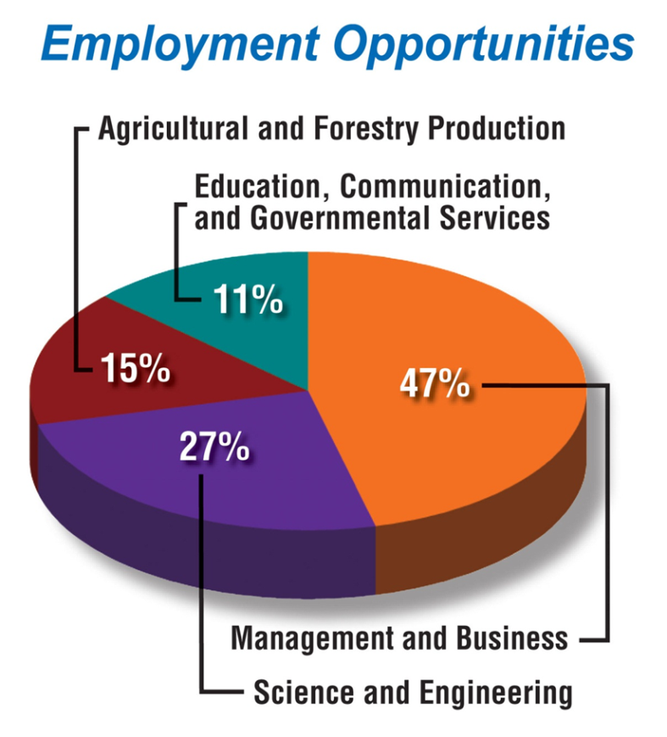
Since the publishing of this projection, they Department of Agriculture has found that even more positions have become available. This study also excluded positions in agriculture that do not require a college education, an amount that is high and represents even more jobs for a lagging economy. Agriculture education teaches many skills that are not taught anywhere else. In a speech delivered in 2010, Secretary of Education Arne Duncan said to a stadium full of students in Ag Ed, “My message to you today is simple. We need you. Our nation needs your skills and talents to compete and prosper in the global economy. Our communities need your leadership and commitment to civic engagement to thrive.” ⁵ It is simple, strong economies have a strong agriculture industry, and the U.S. needs to consider whether or not students are being taught the opportunities and importance of agriculture. The next generation needs to know that not only is agriculture a viable and noble pursuit, but that it is one that will make this country stronger.
Job-Ready, Skills Learned in Agriculture Education/ Technologically Advanced:
In education, “job-ready skills” are a popular buzz word. Ag Ed has the unique opportunity to teach students job ready skills that can enable them to go directly to the work force. This includes such high demand positions as welders, electricians, horticulturalists, and carpenters. Often, skills learned in Ag Ed can also foster skills that give students a competitive edge when going to a technical school, or trade school, such as mechanics or plumbing. ² Skills can also transfer to four year degree programs, such as agriculture systems management or biological engineering. All of these positions are vital for a well-rounded and effective economy and society. To many, agriculture education is the first stepping stone to entering an occupation that may involve ag. Seeing as less than 2% of the population of the US is directly involved in the production of food, fuel, and fiber, ¹ there are many students far removed from the farm. It is a blatant lie, however, if people say that you have to come from a farm to be involved in agriculture. With increasing modernization and innovation, the industry employs numerous different types of positions. Modern ag involves scientists, effective communicators, economists, engineers, animal caretakers, and business people. In a speech, given by Secretary of Education, Arne Duncan, to a stadium full of students who are the products of agriculture education, Duncan said in his welcome,
“I see future farmers and ranchers—and so much more. We have prospective policymakers and physicians here. We have technology experts and teachers, artists and athletes. We have biologists and biochemists, lawmakers and lawyers. Among you are future environmental engineers and energy entrepreneurs. They are all here today.” ⁵ This speech was given at the 83rd National FFA Convention. The FFA is an organization that develops “premier leadership, personal growth, and career success” in students enrolled in Ag Ed across the country.⁶The National FFA Organization started as the Future Farmers of America, but to emphasize the fact that one does not have to be involved in farming to be in agriculture; they changed the official name to National FFA Organization in 1988. ⁶ This internationally recognized group is often quoted by many as cultivating the Future for America, in reference to the original name of Future Farmers of America. This begs the question as to the future of Ag Ed. In order to feed future generations, one must evaluate the importance of raising the next crop of farmers.
Feeding Future Generations:
While some may disagree with current predictions, it is hard to deny the fact that the world’s population is indeed increasing. While people are often concerned about such international issues as food security and water security, government officials rarely talk about agricultural implications. In order to feed a growing population, the ag industry needs even more scientists, business people, and farmers to work together to creatively come up with a solution. The truth is that currently, in the year 2013, there are approximately 6.8 billion people.⁷ About 870 million people, or 1 in 8 humans, suffered from chronic undernourishment last year in 2012. According to the UN 4.17 children are born per second. ⁷ So, if currently the food system in the world is not effectively reaching everyone, how on earth can the problem of feeding future generations be solved if people are not going into agriculture? This is why we, as a society, as a nation that takes pride in education, needs to be thinking about training the next generation of farmers. The next generation that will be feeding and clothing our children. This, unfortunately, isn’t the only obstacle. Part of the trend in the United States and industrialized nations, is simply that young people are not entering agriculture. The map below shows a picture of the United States with the average age of farmers for each county. According to the 2002 Census of Agriculture, the overall, average age is 57, and increasing every year.⁸ On the map, the darker the blue color, the older the average farmer is in that area.⁸ This is indeed a problem in the U.S. that not many people talk about. If farmers continue to age, with no new reinforcements, there will be devastating effects.
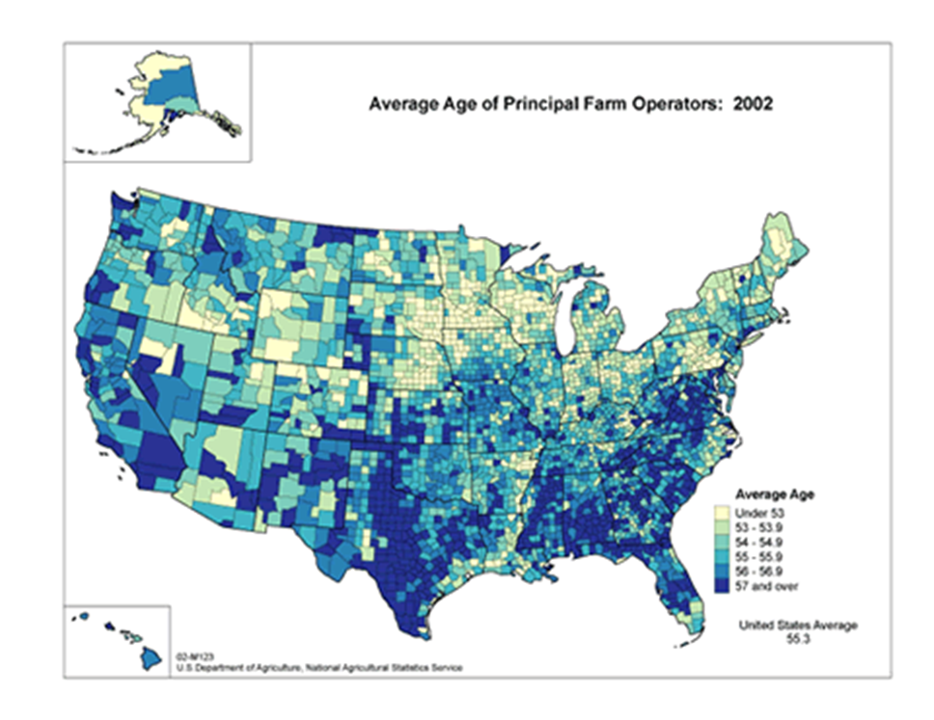
If Americans and the education system do not start to face these facts, the US will certainly not be growing the world’s safest, cheapest, and most abundant food. According to the study conducted by Purdue University and USDA, “The ability to maintain a safe food supply that is more affordable and nutritious while also expanding energy production from renewable sources will increasingly depend upon the strategic integration of action teams. Those teams will need strong research and development and efficient business management skills. There will [also] be growing opportunities for specialists who will manage our nation’s water resources.” ⁴ Without new people entering the industry, this is simply impossible. Who will plant the corn and milk the cows? Who will engineer new tractors and more efficient food processing machines? Who will provide insurance for agribusinesses that serve agriculture? Who will feed the growing population? Who will maintain this great nation’s trees, forests and wild-lands?
Environmentally Friendly Practices:
Having agriculture education will also ultimately create a more environmentally friendly future generation in America. Most current Ag Ed programs in the U.S. have Wildlife and Fisheries classes, as well as important lessons on sustainability and recycling. The detrimental effects that misuse can have on this Earth that 6.8 billion people call home are not just taught, but discussed and deliberated. ² This will become increasingly important as the population increases and people are competing for natural resources. With more American students having a broader base knowledge on green practices and environmental sustainability, we could lead the world in green innovation. Students engaged in water engineering, woodland preservation, and teaching sustainable agricultural practices could help slow the detrimental effects that humans have on the environment.
Educated Consumers:
Even if students decide not to enter into the diverse field of agriculture, having a base knowledge of where their food, fuel, and fiber come from can be exceptionally helpful. This will make students better educated consumers and they will be able to make logical decisions in the grocery store, in feeding their families, and in their impacts on the environment. It truly is a shame that consumers rarely know where their food comes from. Or the materials for clothing. Or the wood for pencils, paper, and buildings, etc. In a 2012 study on consumer purchasing tendencies in the United States, the U.S. Farmers and Ranchers Alliance (USFRA) found some stark contrasts. After many surveys and questionnaires, they found that 72% of consumers admit to knowing nothing or very little about farming or ranching, yet 70 % say they absolutely make purchasing decisions based on how food is grown and raised. ⁹ This contradiction is definitely a problem that agriculture education would solve among US citizens. Being far-removed from the production of food does not have to equal a lack of knowledge.

Possible Problems with implementing Agriculture
Education in the United States, and ways to overcome:

With the end goal of every public school in the nation having agriculture education available for students to take, there are many financial, societal, and logistical barriers to consider.
Finances:
With the current economy and funding available, it may seem like a surprise to suggest such a far reaching proposal. To add Ag Ed to every public school in the nation seems a financially insurmountable task. However, there are definitely some options to make Ag Ed easier to implement in U.S. schools. This proposal definitely calls for support from both the Department of Education and the Department of Agriculture at the federal level. A system that would give grants to schools with economical plans to implement Ag Ed could be given, and schools could also ask for state and local support. The benefits of agriculture education are a wise financial decision. Investing in Ag Ed is investing in the future. It is investing in the future food sources, economy, consumers, and investing in future Americans.
Agriculture Education Teachers & How to Transition Current
School System to Enable Agriculture Education :
The logistics behind a proposal this big may seem daunting. However, in order to examine different ways to add agriculture education to all schools, it is effective to examine current programs in schools that are already established. As of 2012, there are approximately 8,200 current middle and high school Ag Ed programs in the continental US.¹⁰ In order to capitalize on these programs, other schools can look at case studies of successful programs. As for having enough qualified teachers, this is something that will take time to happen. With more rewards for students to enter into the fields of agriculture including Ag Ed, via secondary education scholarships, the number of teachers would increase drastically. There is a myth that Ag Ed is only for rural schools, only for farm-kids. However, there are agriculture education programs in large cities like Philadelphia, Chicago, Detroit, New York, and many more. Although agriculture is seen as solely pertaining to rural areas, every American eats, wears clothing, and uses energy. Transitioning larger, more urban schools to allow agriculture education may be somewhat more difficult. However the benefits outweigh the costs in the new wealth of opportunities for students.
Conclusion:
The Secretary of Education, Duncan himself declared, “The math here is simple. For the U.S. economy to continue to rebound and grow, America's biggest employer [agriculture,] has to help lead the way.” ⁵ Therefore, the education system in America also needs to help students succeed by adding agriculture education to the list of offered classes. The ultimate goal of instilling agriculture education in every school in the United States is not to just to ensure that America grows more crops, but rather that the education system would cultivate students to their utmost growth. So that students may reach their potential. So that the American economy may thrive as an industrious global leader. So that the United States can continue to be food secure as the population continues to increase. So that the next generation will make this great nation more environmentally friendly. Agriculture education can, and will make America a healthier and more prosperous country. Many critics may say that we cannot afford to add this life-changing education to every school in the United States. However, perhaps the real question is, can we as a nation afford not to?

Sources:
1. "United States Agriculture, Facts and Statistics." U.S. Department of Agriculture. United States Department of Agriculture, 2013. Web. 21 Mar. 2013. <http://www.usda.gov/wps/portal/usda/usdahome>.
2. "Agricultural Education." The National Council for Agricultural Education; Team Ag Ed. The Council; A National Partnership For Excellence in Agriculture and Education, 2012. Web. 20 Mar. 2013. <https://www.ffa.org/thecouncil/Pages/ageducation.html>.
3. "Quotations On Agriculture." Thomas Jeffersons Monticello Blog RSS. The Thomas Jefferson Foundation, 2012. Web. 18 Feb. 2013. <http://www.monticello.org/site/jefferson/quotations-agriculture>.
4. Goecker, Purdue University, Allan D., P. Gregory Smith, U.S. Department of Agriculture, NIFA, Ella Smith, U.S. Food and Drug Administration, and Rebecca Goetz, Purdue University. "United States Department of Agriculture - Purdue Agriculture." United States Department of Agriculture - Purdue Agriculture. United States Department of Agriculture; National Institute of Food and Agriculture, 2011. Web. 20 Mar. 2013. <http://www3.ag.purdue.edu/USDA/employment/pages/default.aspx>.
5. Duncan, Arne. "Agricultural Education in the 21st Century: Secretary Arne Duncan's Remarks at the FFA Convention." U.S. Department of Education. Agricultural Education in the 21st Century: Secretary Arne Duncan's Remarks at the FFA Convention, 21 Oct. 2010. Web. 20 Mar. 2013. <http://www.ed.gov/news/speeches/agricultural-education-21st- century-secretary-arne-duncans- remarks-ffa-convention>.
6. "NATIONAL FFA ORGANIZATION |Agricultural Education." FFA. The National FFA Organization, n.d. Web. 21 Mar. 2013. <https://www.ffa.org/Pages/default.aspx>.
7. "FAO Media Centre: Globally Almost 870 Million Chronically Undernourished - New Hunger Report." FAO Media Centre: Globally Almost 870 Million Chronically Undernourished - New Hunger Report. Food and Agriculture Organization of the United Nations, 2012. Web. 01 Dec. 2012. <http://www.fao.org/news/story/en/item/161819/icode/>.
8. Allen, Rich, and Ginger Harris. "Census of Agriculture - 2002 Census Publications - Demographics of U.S. Farm Operators." Census of Agriculture - 2002 Census Publications - Demographics of U.S. Farm Operators. United States Department of Agriculture; National Agricultural Statistics Service, 2008. Web. 20 Mar. 2013. <http://www.agcensus.usda.gov/Publications/2002/Other_Analysis/>.
9. "Nationwide Surveys Reveal Disconnect Between Americans and Their Food." The Food Dialogues: US Farmers and Ranchers Alliance. Survey Findings Released During “The Food Dialogues” Indicate Americans Constantly Think About Food Production Yet Have Little Connection to Farming or Ranching; Respondents Split on Whether Agriculture Is Improving or Heading in Wrong Direction, 22 Sept. 2011. Web. 21 Mar. 2013. <http://www.fooddialogues.com/news/2011/09/22/nationwide-surveys-reveal- disconnect-between-Americans-and-their-food>.
10. "Teach Ag." Teach Ag. National Association of Agriculture Educators, n.d. Web. 21 Mar. 2013. <http://www.naae.org/teachag/faq.php>.

