Sarabeth Royer

Fall 2012

Professor Bedell

Consumer Views and Consequential Effects

On the Food Industry

Every day, at least three times a day, people open the fridge, a menu, a can, or a jar and either prepare, order, or make food. Meals are something that people take a part in all the time, but do American consumers really think about what they are eating? Where did this come from? Who planted, harvested, and produced this food? Was it processed in a factory? Are there traces of pesticides or chemicals in it? What processes were used in order for us all to enjoy this cereal, pasta, vegetables, or milk? How many times a day does the average American consumer ask themselves, what am I really eating?

With such food fads as vegetarianism, organic, buying local, being a vegan, and only eating kosher, there are obviously many factors contributing to consumers eating habits. Religious practices, health ideals, and morality are just a few. So, what other factors contribute to the eating trends in the United States? Why in the past 30 years has eating organic and vegan become so popular? If eating healthy is such a priority, why is America experiencing such an obesity epidemic? As a result of Americans spending less time preparing food than their ancestors did, they are more inclined to make food buying decisions based on media portrayals of, and their own perceptions of agriculture, biotechnology, and the food processing industry.

The Changing of Time:

In order to accurately portray the current trends in consumer spending, perceptions, and views of food today, it is important to look at the past as well. A century ago, in 1912, the average American lived on a farm and produced most of their food. Daily chores may have included milking the cow whose milk they would use to make butter, cheese, etc. and hoeing the garden full of vegetables. Fast Forward to the 1940s in the midst of World War II, and “fast food” restaurants emerge. Women, having to pick up jobs their husbands, sons, and brothers left behind when they went to war, had less time to make supper. (Wood) This was a time saver, literally getting food fast. This time period also, ironically, is well known for it’s Victory Gardens, meant to boost morale at the home front during WWII, as well as promote making more food within the United States (Wood). This juxtaposition, of healthy home grown vegetables in comparison to densely fat and protein filled fast food, only widens as time continues. The 1950’s and 1960’s represents the iconic “American Family” era in which mother’s had supper on the table promptly at 5:00 with a meat, a vegetable, and a starch (Wood). This iconic image and diner tradition dwindled as the American family became more diverse and modern. In the USDA publication, “Who Has Time to Cook? How Family Resources Influence Food Preparation” researchers Lisa Mancino and Constance Newman examine the trend in the United States of taking less time to prepare food. The paper states,

Households participating in the Food Stamp Program are increasingly headed by a single parent or two-working parents. As this trend continues, more low-income families may find it difficult to allocate the time needed to prepare meals that fit within a limited budget and meet dietary requirements. (pg i)

Similar studies have concluded the same primary issue in preparing food in today’s culture, time! With more and more households containing two working parents, and a growing number of women having careers outside the home, the time spent preparing food has drastically dropped in the past century.

This graph clearly demonstrates how simply in the last forty years, the amount of time women spend preparing food has decreased substantially, without compensation from men. This research paper by Cathleen D. Zick and Robert B Stevens also explored the time spent eating, and whether or not this is time spent solely on ingesting food. The results concluded that in the past forty years, the amount of time spent eating has increased overall, as well as the time spent eating while also doing something else, such as watching TV, working, or listening to music. (Zick) This is important to note because studies have also shown that people who “eat secondary time,” meaning they are attempting to accomplish something else while eating, will ingest more calories than normal. Their brains, shifting focus from their filling stomachs, will not send the message to stop eating (Zich).

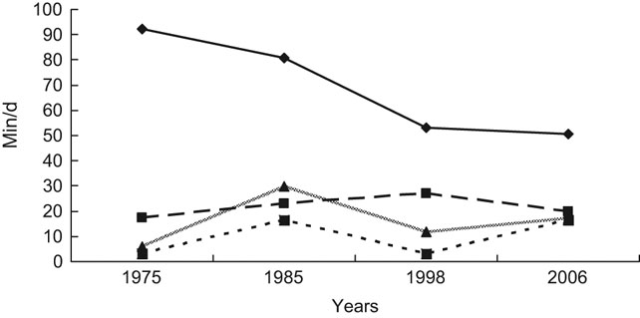 Trends in mean food preparation and grocery shopping time (S1368980009992138_eqnU9, women food preparation; S1368980009992138_eqnU10, men food preparation; S1368980009992138_eqnU11, women grocery shopping; S1368980009992138_eqnU12, men grocery shopping) (Figure 3, Zick)

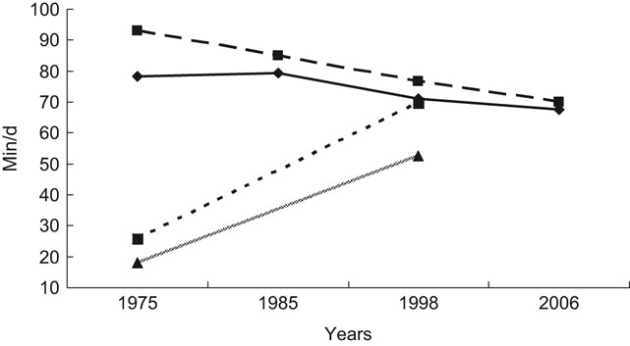

Trends in mean time spent eating (S1368980009992138_eqnU1, men primary time; S1368980009992138_eqnU2, women primary time; S1368980009992138_eqnU3, men secondary time; S1368980009992138_eqnU4, women secondary time) (Figure 1, Zick)

Therefore, with contributing factors of people having busier schedules, more women having careers outside of the home, and other available options of places to eat, the average American household is spending less time preparing food, grocery shopping, and eating together, and spending more time multi-tasking and ingesting excessive calories.

Foods Fads and Facts

A recent study by Elanco, a global company that develops and markets animal medical products and improvements for protein production, states that “Factors Influencing Food Purchase Decisions” for American consumers in 2012 were 43.88% Taste, 31.51% Cost, 23.02% Nutrition, and 1.99% Other. The Other category might include very strict vegetarian, organic, and vegan diets. (Simmons) The Elanco Report categorizes consumers into two categories, “Food Buyers” (95% of consumers) which choose foods based on taste, cost, and nutrition disregarding modern agriculture or food production practices. “Lifestyle Buyers” consisting of about 4% of the population who purchase food based on ideals and morals relating to their lifestyles. Money is not an issue and they are willing and able to pay more for organic, local, hormone free food, etc. (Simmons) The remaining 1% consists of consumers with very strict bans on certain foods. Consumer choice is a very important not only for the American economy but the worldwide food industry.

Another, sociologically based study of consumer trends declares, “[t]he social value attached to food, health and physical beauty has risen constantly in the second half of the twentieth Century” (Mennel, pg 36) This is an important shift to note. A century ago, food represented survival. A family needed to produce enough food to survive through the winter. Then, by the midcentury, eating was a family affair. Dinner was every night with Mom, Dad and the siblings. However, this view of food has shifted. As the average American consumer gets further and further away from the production of food, and the ideal family diner gets replaced by frozen dinners and organic food, clearly different lifestyles have evolved with food as well. Because the truth is, there are very different views on eating in America. Some people chose to eat organic, which is food produced and processed without the use of chemical fertilizers, pesticides, or other un-natural agents (Oxford). Others adopt a vegan diet, which is not using or eating animal products (there are varying forms of vegans, some may use, but not eat animal products) (Oxford). One could argue that these lifestyle consumers, while some may be in the 1% very strict portion of the population, are simply wanting to go back to the old times, when everyone had fresh food. When everyone had a garden and there were not as many chemicals in foods. This nostalgia is also highlighted in the “Buy Local, Buy Fresh” idea. People are willing to pay more for food, if they know where it comes from, who grew it and who processed it. Food, to some, is easier to swallow and better for you if your neighbor made it. There are many very concerned about their health and body image, some are concerned about chemicals and animal rights, and others concerned solely on taste and speed of preparation.

Yet, this vocal minority of consumers extremely concerned about health seems to contradict the obesity dilemma plaguing the United States.

Results from the 2009–2010 National Health and Nutrition Examination Survey (NHANES), using measured heights and weights, indicate that an estimated 33.0% of U.S. adults aged 20 and over are overweight, 35.7% are obese, and 6.3% are extremely obese. (Prevalence)

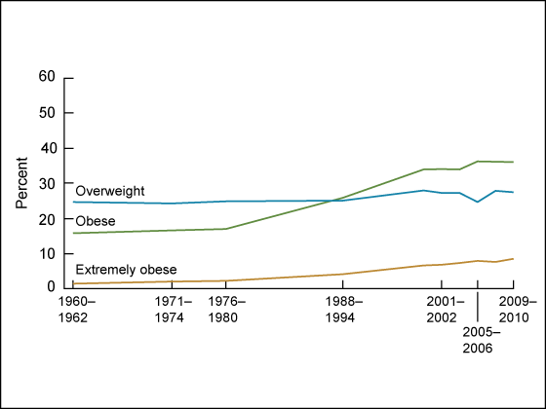

Trends in overweight, obesity, and extreme obesity among women aged 20–74 years: United States, 1960–1962 through 2009–2010 (Figure 1, Prevalence)

This represents a prominent shift in not only the food industry, but the health of consumers in the United States. One cannot deny the relationship between the amount of time spent eating and the time spent preparing food, with the weight and health of Americans. This is obviously not the only issue regarding the obesity epidemic, but should not be discounted as a cause.

Labels: The Confusing Marketing Stickers

Food labels; they are something meant to help consumers make decisions while buying food, yet are often confusing, misleading, or perceived incorrectly. For instance, many people are adamant about buying Reduced Fat Milk, but would not be able to tell the difference between Fat Free and Reduced Fat. Many consumers are extremely concerned about the nutritional value of their food. It is important to note that confusion about a products origin will affect whether or not people buy something, and ignorance of

an issue does not stop consumers from making decisions. For instance, the IFIC conducted a telephone survey asking consumers whether or not they had ever eaten something made from biotechnology.Biotechnology can be defined as “the exploitation of biological processes for industrial and other purposes, especially the genetic manipulation of microorganisms for the production of antibiotics, hormones,”(Oxford) Most often in agriculture and food processes, it used to genetically engineer better, more nutritious vegetables, fruits, animals, plants, etc. Here are some of the results from the IFIC study.



***(Among those who said “yes”)*** Biotech Foods **Believed** to Be Available in the Supermarket:

**Vegetables 37%**

**Corn/Corn products 21%**

**Fruits 19%**

**Meats/Eggs/Fish 14%**

**Tomatoes 10%**

**Cereals/Grains 4%**

**Milk/Dairy 4%**

**Soy 4%**

**Potatoes 1%**

**Processed Foods <1%**

**Other 7%**

James (Chart courtesy of Dr. Terry Etherton, Head of the Animal Sciences Dept. at the Pennsylvania State University)

This means that 74% of Americans believe they have never had food that was genetically engineered in some sense. This is highly unlikely considering 32% of all corn in the world has higher production rates thanks to biotechnology. Also 82% of cotton, 75% of soybeans, and many more vital products have increased in nutritional value, productivity, and reproducibility through biotechnology. (James) Thanks to biotechnology, farmers can produce the same gallon of milk today with 90% less land and 65% less water than compared to a gallon in 1944. (Simmons) Biotechnology is very important to increase production and efficiency in order to feed everyone, however, many consumers either don’t know what it is, or think of the science very negatively.

The truth of the matter is that food labels in many ways are a confusing marketing tools. Food labels are marketing tools that many consumers simply misconstrue as simple legitimate fact. The media also often highlights incorrect or false claims relating to food products. The difference between Whole Wheat bread and Wheat Bread is a prime example. Whole Wheat Bread contains all 3 parts of a wheat kernel, whereas wheat bread may simply be enriched and colored white bread! A Marketing and Behavior Group in the Netherlands recently conducted an experiment to look at consumers perceptions of food labels.

Visual search paradigm was applied as an effective experimental tool to investigate what attracts consumer attention to labels. It was found that label characteristics (e.g., display size, position of the label on FOP, colour scheme); and familiarity with the type of the logo and the location it appears in are key determinants of attention to labels. (Bialkova)

The research also showed that the logo and label trumped any nutritious information almost every time. Now, whether or not this is because shoppers are trying to speed up the process of grocery shopping, or they simply didn’t understand the labels was not identified. One could argue it is both.

Another study looked at the different marketing tools used on products. “Nutrition marketing can be defined as any marketing (including marketing on television, radio, or food labels) of food or beverages using health or nutrition information beyond minimum requirements.” (Colby)For example, sayings like “good source of protein,” this is confusing and misleading because what is defined as “good.” Or the phrase, “100% Vitamin C,” is misleading because most consumers assume this will keep them healthy, or at least stop a cold. (Colby) The Food and Drug Administration (FDA) regulates labeling on packaged food, however, there are loopholes that marketing strategies can overcome. Commercials on T.V. and radio, adds in magazines and newspapers are all tailored to make consumers believe a product is not only delicious, but often healthy and nutritious.

Health claims can alter consumers' perceptions toward specific food products.  Research has shown that products with health information on the labels influence consumer knowledge and behavior as well as company profits. …Increased consumer use of labeling information is related to having a higher quality diet. Although most consumers use food labels, those with higher levels of healthful eating behaviors, self-efficacy, beliefs in diet–disease linkage, and weight loss goals are more likely to use labels, whereas the majority of consumers cannot correctly interpret labeling information. (Colby)

This research indicates that not only are consumers susceptible to misinformation, but consequently make food buying decisions based on these misconceptions. Increased knowledge of labels and food products allows for consumers to ascertain the best food products to buy. Unfortunately, the average American consumer not only lacks the appropriate knowledge, but as stated before, rarely takes the time to even check labels closely while grocery shopping.

Over the past century there definitely has been a shift in the business of food. How Americans, grow, consume, prepare, and perceive food represents a paradigm shift that mirrors the changing population. The interesting studies conducted in this field have concluded that many factors have contributed to these stark changes in eating habits. The time spent shopping for food, and preparing meals has decreased drastically, while the amount of time spent eating has increased. This, combined with food labeling has changed the way Americans perceive food. Consumer choice to buy organic, local, and other food types has increased in popularity, while consumers knowledge of modern agricultural practices such as biotechnology remains limited. The time spent preparing and eating food, along with labels on foods purchased, all have a large impact on consumer buying. This demonstrates how food fads do not always follow the facts.

Sources Cited

Bialkova, Svetlana, and Hans van Trijp. "What Determines Consumer Attention to Nutrition Labels?" Food Quality and Preference 21.8 (2010): 1042-51. Print.    
Colby, Sarah E., et al. "Nutrition Marketing on Food Labels." Journal of Nutrition Education and Behavior 42.2 (2010): 92-8. Print.

James, Clive, Dr. "USDA Crop Acreage Report for 2012, Confirms That US Farmers Continue to Demonstrate Overwhelming Trust and Confidence in Biotech Crops." *: August 17, 2012*. ISAAA, 17 Aug. 2012. Web. 22 Oct. 2012. <http://www.isaaa.org/kc/cropbiotechupdate/ pressrelease /2012/default.asp>.

Mancino, Lisa, and Constance Newman. "Who Has Time to Cook? How Family Resources Influence Food Preparation." *USDA*. United States Department of Agriculture; Economic Research Service, 2007. Web. 21 Oct. 2012. <http://books.google.com/books?hl=en>.

Mennell S, Murcott A, van Otterloo A. Nutritional Trends. Current Sociology. 1992;40:35-41.

"Prevalence of Overweight, Obesity, and Extreme Obesity Among Adults; United States, Trends 1960- 1962 Through 2009-2010." *Centers for Disease Control and Prevention*. Centers for Disease Control and Prevention, 13 Sept. 2012. Web. 22 Oct. 2012. <http://www.cdc.gov/nchs/data/hestat/obesity\_adult\_09\_10/obesity\_adult\_09\_10.htm>.

"The Oxford English Dictionary." *- Oxford Dictionaries Online*. N.p., n.d. Web. 18 Oct. 2012. <http://oxforddictionaries.com/words/the-oxford-english-dictionary>.

Simmons, Jeff. “Technology’s Role in the 21st Century: Making Safe, Affordable, and Abundant Food a Global Reality.” Elanco Animal Health. 2011

Wood, Chris. "When Food Became Fast!" *- Restaurants of the 1950’s: Fast Food Is Born*. Rewind the Fifties, 2007. Web. 20 Oct. 2012. <http://www.loti.com/fifties\_food/When\_Food\_Became \_Fast.htm>.

Zick CD, Stevens RB. Trends in Americans’ food-related time use: 1975-2006. Public health nutrition. 2010;13:1064-1072.